A
“PROJECT REPORT”

ON

“Expanse Manager”

SUBMITETED TO FULFILLMENT OF MASTER OFCOMPUTER APPLICATION

AT


BY
REDEKAR SAIRAM MARUTI
[PRN:SOM2022M0508076]

2023-2024

Ref No: DYPSOM/MCA Date:

CERTIFICATE

This is to be certify Mr. Redekar Sairam Maruti is a bonafide student of School of Management, D. Y. Patil University Ambi, Pune. He has successfully completed the project “ Expanse Manager ” .

This Project is submitted for the partial fulfilment of the award of the degree of Master of Computer Application (Semester III) under D. Y. Patil University for the academic year 2023 – 2024.

Dr. Amit Jadhav Dr. Prof Anup Shivanechari
Project Guide HOD – MCA

DECLARATION

TO
The Director
D.Y. Patil School of Management, Ambi.
Respected Sir,
I undersigned hereby declare that the project entitled “Expanse Manager” is purely done by me under the guidance of "Dr. Prof. Amit Jadhav." and submitted for the partial fulfillment of the award of the degree of Master in Computer Application (Semester IV) under the D.Y. Patil University for the academic year 2023 / 2024.This project work is original to the best of my knowledge and is not submitted anywhere else.

Yours Sincerely

ACKNOWLEDGEMENT

I have taken efforts in this project . However , it would not have been possible without the kind support and help of my supervisor , fellow classmates and my project partner. I would like to extent my sincere thanks to all of them.
Highly thanks to my supervisior “Dr. Amit Jadhav for their guidance and supervision as well as for providing necessary information regarding the project and also for their support in completing the project.

Your sincerely
Redekar Sairam Maruti
(PRN:SOM2022M0508133)

D.Y. PATIL UNIVERSITY, AMBI, PUNE
SCHOOL OF MANAGEMET
Date:

Table of Content

Sr. No. | Title | Page No.
1 | INTRODUCTION | 6 - 8
1.1 | PROBLEM STATEMENT | 6
1.2 | EXISTING SYSTEM AND NEED FOR SYSTEM | 6
1.3 | OPERATING ENVIRONMENT – HARDWARE AND SOFTWARE | 7
1.4 | SCOPE OF WORK | 7
2 | PROPOSED SYSTEM | 9 - 10
2.1 | PROPOSED SYSTEM | 9
2.2 | OBJECTIVE OF SYSTEM | 9
2.3 | USER REQUIREMENTS | 10
3 | ANALYSIS AND DESIGN | 11 - 14
3.1 | USE CASE DIAGRAM | 11
3.2 | SYSTEM SEQUENCE DIAGRAM | 11
3.3 | ENTIITY RELATIONSHIP DIAGRAM (ERD) | 12
3.4 | MENU SCREENS | 12 - 14
4 | USER MANUAL | 14
5 | DRAWBACKS AND LIMITATIONS | 15
6 | PROPOSED ENHANCEMENTS | 15
7 | CONCLUSIONS | 15
8 | BIBLIOGRAPHY | 16

- INTRODUCTION

  - Problem Statement

Numerous organizations recognize the pivotal role that tracking income and expenses plays in gauging their overall business progress. While it is considered a commendable habit for individuals to diligently record their daily financial activities, the prevalent use of traditional note-keeping methods is often attributed to a lack of awareness and suitable applications that prioritize user privacy. In many instances, individuals find themselves grappling with decisionmaking challenges, further compounded by the absence of comprehensive tracking systems. This reliance on daily entries and end-of-month estimations creates a perpetual burden, highlighting the need for a more efficient and user-friendly solution that addresses the complexities of financial management. Embracing modern technologies could significantly alleviate these challenges, offering users a seamless and insightful experience in managing their finances.

  - Existing System

Various organizations have established their proprietary systems to meticulously record both income and expenses, considering these records as integral to assessing the overall progress of their businesses. On an individual level, cultivating the habit of documenting daily expenses and earnings is widely acknowledged as beneficial. However, a prevalent reliance on traditional note-keeping methods persists due to a lack of awareness about more sophisticated alternatives and the absence of applications designed to prioritize user privacy.

Additionally, the decision-making capacity of users is often hindered by the limitations of existing systems. These systems lack the completeness required for effective financial tracking, leading individuals to bear a constant load of daily expenditure entries and end-ofmonth estimations. Recognizing the need for a more sophisticated approach, especially in the mobile domain, Android expense tracker projects aim to fill this gap. By leveraging the capabilities of the Android platform, developers seek to provide users with a comprehensive and user-friendly system that addresses the challenges posed by conventional methods. These Android expense tracker applications offer a modern solution, allowing individuals to manage their finances efficiently, automate repetitive tasks, and gain valuable insights into their spending patterns.

  - Need for System

The imperative need for an Android expense tracker system stems from the inherent challenges and inefficiencies associated with conventional methods of financial management. Existing systems often rely on traditional note-keeping, creating a cumbersome process marked by manual entries and end-of-month estimations. This outdated approach leads to a lack of realtime visibility into financial activities, hindering users' ability to make informed decisions promptly. Furthermore, the absence of user-friendly applications tailored to safeguard privacy exacerbates the problem, contributing to a pervasive unawareness about the benefits of modern tracking systems. Recognizing the shortcomings of these outdated practices, the Android expense tracker project seeks to bridge this gap by offering a sophisticated, user-centric solution that leverages the capabilities of the Android platform.

In developing this system, the goal is to empower individuals and organizations with a comprehensive tool that not only streamlines the recording of income and expenses but also enhances decision-making capabilities. The Android expense tracker will provide users with a seamless and intuitive interface, eliminating the complexities associated with manual data entry. The system's real-time tracking features will ensure accurate and up-to-date financial insights, enabling users to make informed decisions promptly. With a focus on privacy and user experience, this project aims to transform financial management for both individuals and organizations, promoting a habit of proactive and efficient expense tracking.

  - Scope of Work

The scope of the Android expense tracker project encompasses the development and implementation of a comprehensive mobile application designed to streamline and enhance the financial management processes for individuals and organizations. The project aims to address the limitations associated with traditional note-keeping methods and outdated financial systems. Key aspects of the project's scope include:

1. User-Friendly Interface: Design an intuitive and user-friendly interface for seamless navigation and efficient data entry.

2. Real-Time Tracking: Implement features for real-time expense tracking to provide users with up-to-date insights into their financial activities. Ensure accuracy and prompt visibility of income and expenses to facilitate informed decision-making.

3. Privacy and Security: Integrate robust security measures to safeguard user data and build trust in the application. 4. Automation and Efficiency: Include automation features to reduce manual data entry, such as recurring transactions and smart suggestions for categorization. 5. Decision-Making Support: Integrate data analytics to offer insights into spending patterns, trends, and personalized recommendations. 6. Cross-Platform Compatibility: Consider extending the application's compatibility to multiple platforms, ensuring broader accessibility for users on various devices.

7. Scalability: Design the project with scalability in mind, allowing for future enhancements and updates to meet evolving user needs and technological advancements.

  - Operating Environment

Hardware

Processor : Snapdragon 447 or above

Speed : 2.30 GHz

Hard Disk : 10 GB or above

Memory : 2GB RAM or above

Software

Operating System : Android, Ios

Technology : Android Studio

Language : Java, XML

DataBase : FireBase

Browser : Google Chrome, Microsoft Edge, Mozilla Firefox Technology

2. Proposed System

2.1 Proposed System
The proposed Android expense tracker system seeks to revolutionize traditional financial management practices by providing individuals and organizations with a user-friendly and efficient solution. The system will feature an intuitive interface for seamless navigation and data entry, ensuring a positive user experience. Real-time expense tracking capabilities will be integrated to offer users up-to-date insights into their financial activities, facilitating informed decision-making.
Emphasis will be placed on privacy and security, with the implementation of robust measures to protect user data and build trust. Automation features, such as recurring transactions and smart categorization suggestions, will enhance efficiency, reducing the manual burden on users. The system will also include data analytics to deliver insights into spending patterns and personalized recommendations, empowering users to make informed financial decisions.
Cross-platform compatibility will be considered to ensure accessibility across various devices, and a notification system will alert users to important financial milestones and upcoming bills. Cloud integration will enable data synchronization for backup and seamless access from multiple devices. The proposed system aims to not only streamline the expense tracking process but also educate users on its benefits, fostering a proactive approach to financial management. Scalability will be a key consideration, allowing for future enhancements to meet evolving user needs and technological advancements.

2.2 Objectives of System
The primary objectives of the proposed Android expense tracker system are to:
- Streamline Financial Management: Simplify the process of recording income and expenses for both individuals and organizations. Minimize the manual effort involved in traditional note-keeping methods, leading to a more efficient and time-saving financial tracking experience.
- Enhance Decision-Making: Provide users with real-time insights into their financial activities, enabling informed and timely decision-making. Utilize data analytics to offer personalized recommendations and insights into spending patterns, empowering users to make strategic financial decisions.
- Ensure Privacy and Security: Implement robust security measures, including encryption and adherence to data protection best practices, to safeguard user information and build trust in the application.
- Improve User Experience: Develop an intuitive and user-friendly interface, fostering a positive and seamless user experience. Educate users about the benefits of systematic expense tracking through in-app resources, encouraging the adoption of proactive financial management habits.

2.3 User Requirements

Device and Internet Connection: Users need access to a device such as a computer, laptop, smartphone, or tablet with a compatible operating system (e.g., Windows, macOS, iOS, Android) and a stable internet connection.
Web Browser: Users must have a web browser installed on their device. Popular web browsers include Google Chrome, Mozilla Firefox, Apple Safari, and Microsoft Edge. The website should be compatible with the browser versions supported by the website..
Minimum Technical Specifications: Some websites may have specific technical requirements, such as a minimum screen resolution, JavaScript enabled, or specific browser plugins. Users should ensure that their device meets these technical specifications.
User Accounts: Certain websites may require users to create an account to access specific features or content. In such cases, users need to provide necessary information like username, email address, and password during the registration process.
3. ANALYSIS & DESIGN

3.1 USE CASE DIAGRAM
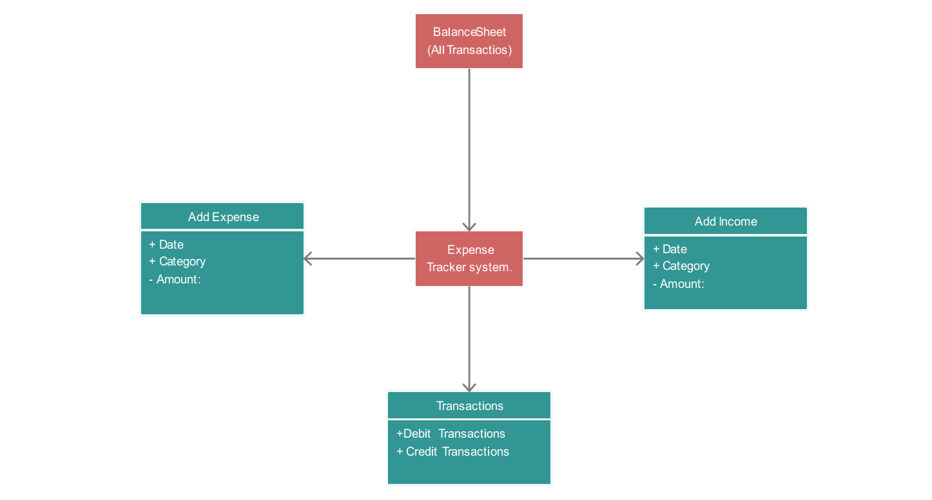

3.2 SYSTEM SEQUENCE DIAGRAM (SSD)
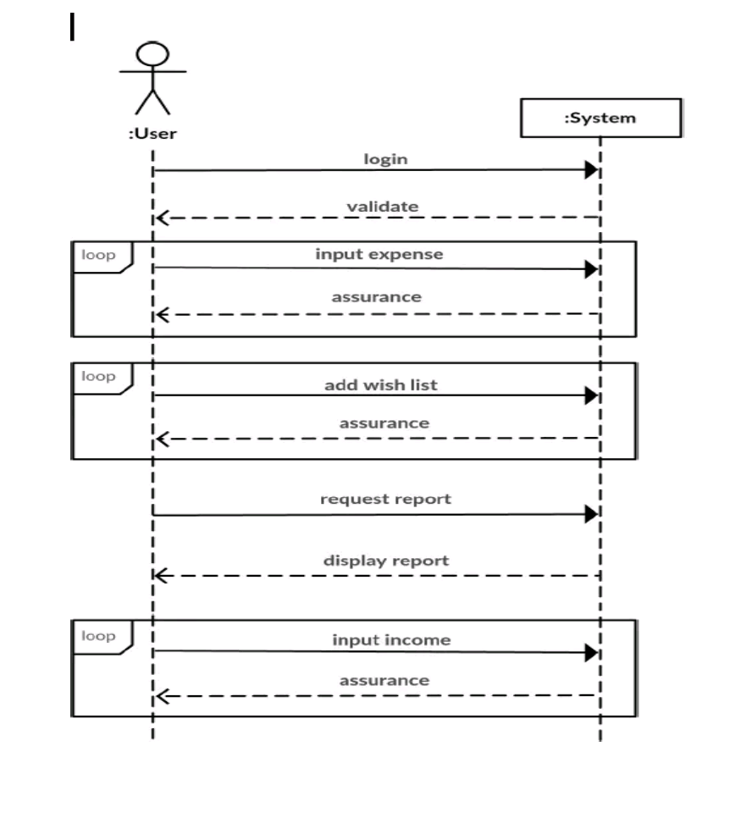
3.3 Entity Relationship Diagram (ERD)

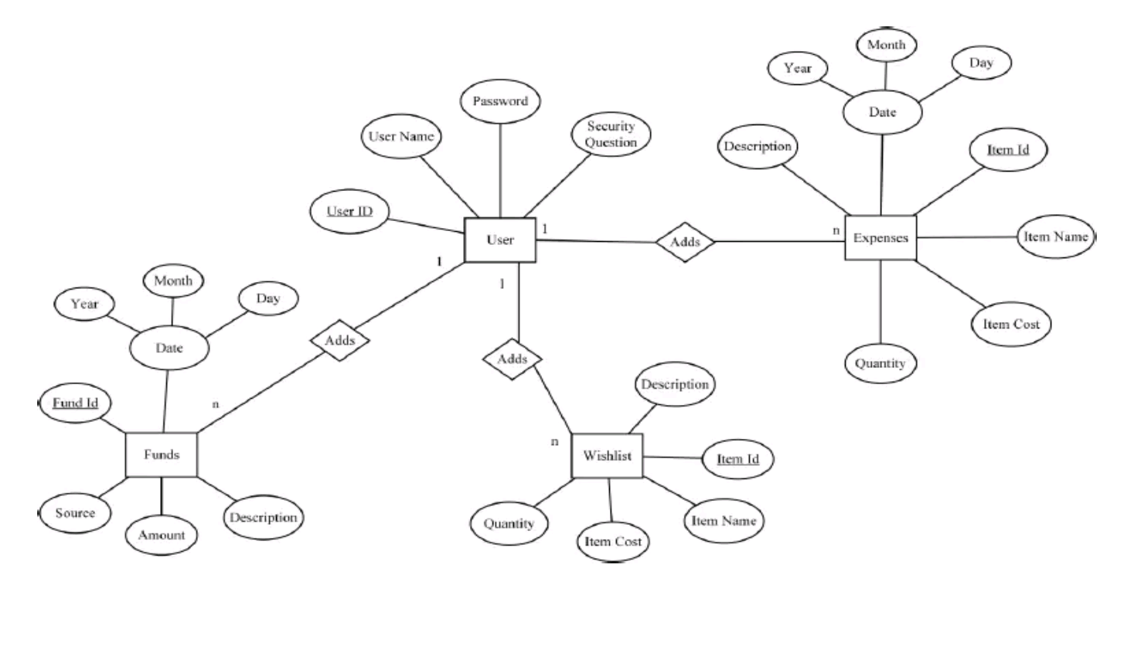

  - MENU SCREENS

3.4.1 SignUp page :
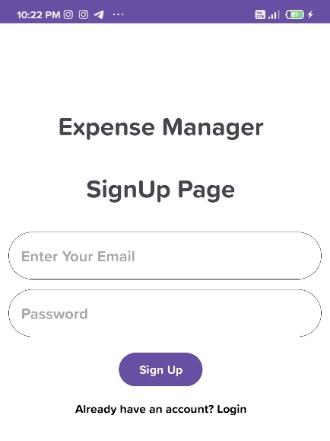

3.4.2 LogIn page :

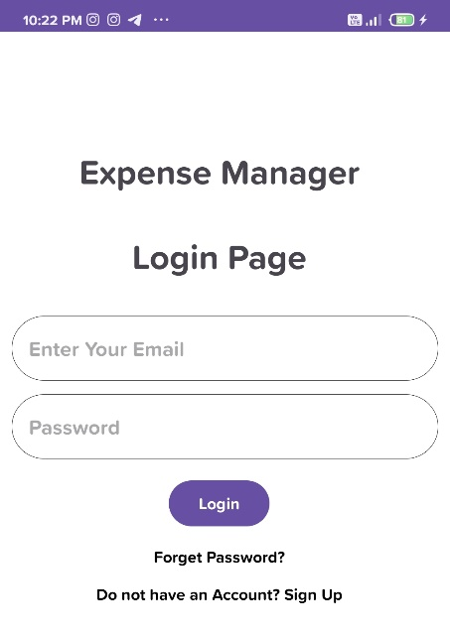

3.4.3 Dashboard :
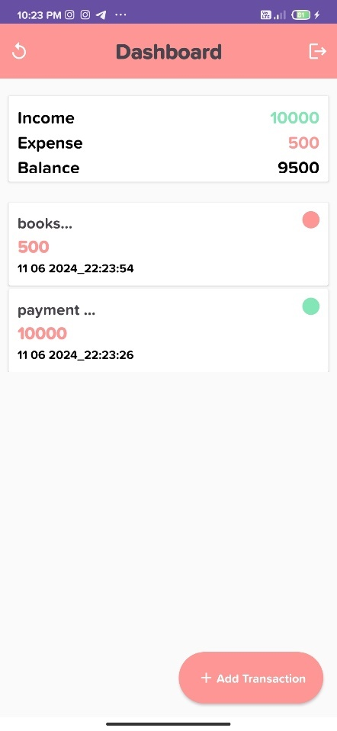

3.4.4 Add Transaction Or Update & Delete :

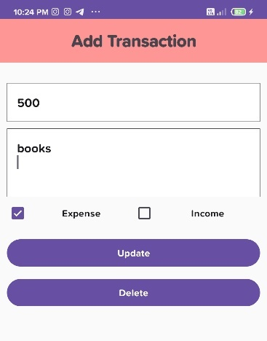

4. User Manual:

Expense Management User Manual Table
of Contents:

1. Introduction

2. Getting Started
2.1. Accessing the App
2.2. Sign Up or Login User
2.3. Dashboard

3. Transaction
3.1. Add Transaction
3.2. Transaction Description
3.3. Category of Transaction

4. Update and Delete Transaction
4.1. Updating the Income and Expense
4.2. Deleting the transaction

5. Logout

5. Limitations:

1. Dependency on User Input: Expense trackers rely heavily on accurate and consistent user input. If users forget to record transactions or input incorrect data, the app's insights may become unreliable.

2. Security Concerns: Storing financial data within an app raises security concerns. Despite encryption and security protocols, there's always a risk of data breaches, especially if the app is not well-secured.

3. Learning Curve: Some users, particularly those not familiar with technology, might find it challenging to navigate and use the app effectively, reducing its accessibility.

4. Limited Accountability: While the app can provide insights, it doesn't enforce financial discipline. Users might not alter their spending habits even after seeing the data, limiting behavioral changes.

6. Proposed Enhancements

Enhancing an Expense Manager Android app can provide users with a more efficient and user friendly experience. Here are some proposed enhancements:

1. User Interface (UI) Improvements: Intuitive Design: Ensure a clean and intuitive design that makes it easy for users to navigate and input data.

2. Expense Entry Enhancements: Smart Autofill: Implement autofill suggestions based on the user's previous entries to save time and reduce manual input errors.

3. Budgeting Features: Customizable Budgets: Allow users to set personalized budgets for different expense categories.

4. Cloud Integration: Sync Across Devices: Enable users to sync their expense data across multiple devices, ensuring they have access to their financial information wherever they go.

5. Expense Analysis: Advanced Reporting: Include detailed expense reports with filtering options, such as by date range, category, or payment method.

7. Conclusion:

In conclusion, the Expense Tracker app represents a pivotal step toward empowering individuals with the tools and knowledge needed for effective financial management. By providing user-friendly interface, robust features, and insightful analytics, this application equips users with the ability to take control of their expenses, set realistic budgets, and plan for a secure financial future. The app's impact extends beyond the realm of personal finance, contributing to a society where individuals make informed financial decisions, reduce stress, and work toward achieving their financial goals.

As we conclude this project, we acknowledge the transformative potential of the Expense Tracker app. It not only simplifies expense tracking but also promotes financial well-being, thereby enhancing the overall quality of life for its users. With its deployment, we embark on a journey toward a financially empowered and responsible community, one user at a time.

8. Reference & Bibliography:

1. YouTube – Available at: [ https://www.Youtube.com]\
2. Google – Available at: [ https://www.google.com]
3. ChatGPT – Available at: [https://www.chat.openai.com]
4. Wikipedia [www.wikipedia.com]
5. Android studio [https://developer.android.com/studio/releases]

